**Experiment 5**

**Aim of the Experiment**

To Study different types of Sensors and the Interfacing of sensors to Arduino Uno and Arduino Nano Board.

**Objective**

1. To Study different types of sensors and their working with Arduino Uno.
2. To Study MQ-2 sensor (gas sensor)
3. To understand the sensor and its working.
4. To use sensors for real-time applications: MQ2 Gas sensor interfacing with Arduino: To Detect gas, smoke, Alcohol.

**Software/Hardware Required:** Breadboard, MQ-2 sensor (gas sensor), Arduino Board, USB Cable, LED, Male to Female Jumper Wires, Buzzer Etc.

C programming language, Arduino IDE

**Theory:**

Sensors are components that enable the conversion of physical phenomena into measurable electrical signals. Arduino Uno and Arduino Nano are versatile microcontroller platforms that can interface with sensors to collect data and perform actions based on that data. This experiment aims to explore various sensor types and focus on the MQ-2 gas sensor's principles and real-time applications through interfacing with Arduino boards.

MQ-2 gas sensor is a critical component in gas detection systems, finding wide application in safety, environmental monitoring, and industrial settings. This write-up delves into the working principles, structure, characteristics, and applications of the MQ-2 gas sensor. By exploring its inner workings and practical applications, we can gain insights into its effectiveness and limitations, paving the way for informed utilization in various scenarios.

**Sensing Output:**

The MQ2 Gas sensor provides both analog and digital outputs. The analog output (AOUT) provides a voltage signal that varies with the gas concentration. The higher the gas concentration, the higher the voltage output. The digital output (DOUT) provides a simple logic signal (LOW or HIGH) based on whether the gas concentration exceeds a certain threshold.

**Principles of Operation:** The MQ-2 gas sensor is based on the principle of chemiresistive sensing. It comprises a sensing element made of a tin dioxide (SnO2) semiconductor, which has the property of altering its electrical resistance in the presence of specific gasses. The sensor's resistance decreases when it interacts with gasses that are oxidizing in nature (e.g., LPG, hydrogen, alcohol), causing a change in its conductivity.

**Structure and Working Mechanism:**

1. **Heating Element:** The MQ-2 sensor incorporates an internal heater that is used to maintain the sensing element at an elevated temperature, typically around 200-300°C. This controlled temperature enhances the sensitivity of the sensor to gas molecules.
2. **Sensing Layer:** The tin dioxide semiconductor acts as the sensing layer. In the presence of the target gas, the gas molecules are adsorbed onto the surface of the sensing layer, altering its electrical resistance.
3. **Gas Interaction:** When the target gas comes into contact with the sensing layer, chemical reactions occur between the gas molecules and the tin dioxide. These reactions lead to a change in the number of charge carriers within the semiconductor, causing a measurable shift in resistance.
4. **Signal Processing:** The sensor's resistance change is converted into an analog voltage output that can be read by a microcontroller or other processing units. The magnitude of the resistance change corresponds to the concentration of the target gas.

**Characteristics/Features:**

1. **Sensitivity and Selectivity:** The MQ-2 sensor is sensitive to a range of gasses, making it suitable for detecting various types of combustible gasses and fumes. However, its sensitivity can vary for different gasses.
2. **Warm-Up Time:** The sensor requires a warm-up time to stabilize its internal temperature. Accurate readings are obtained once the sensor reaches its operating temperature.
3. **Calibration:** Calibrating the sensor to a known concentration of the target gas improves accuracy. However, the sensor's sensitivity can drift over time, necessitating periodic recalibration.

**Applications:** The MQ-2 gas sensor finds application in:

1. **Home and industrial gas leak detectors**
2. **Fire detection and alarm systems**
3. **Gas stoves and cooktops for safety**
4. **Automotive emissions monitoring**
5. **Indoor air quality assessment**
6. **Early warning systems in hazardous environments**

**Circuit Diagram:**

**Code Screenshot:**

**Output:**

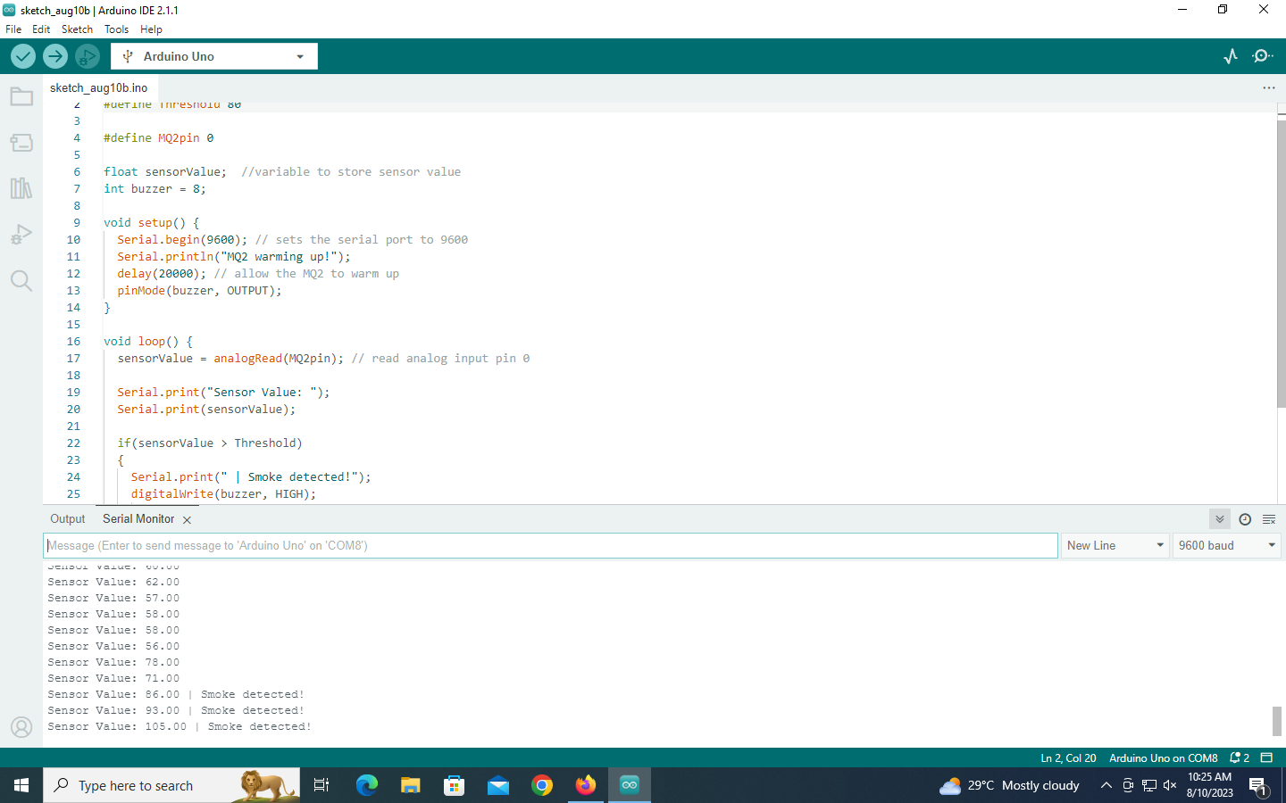

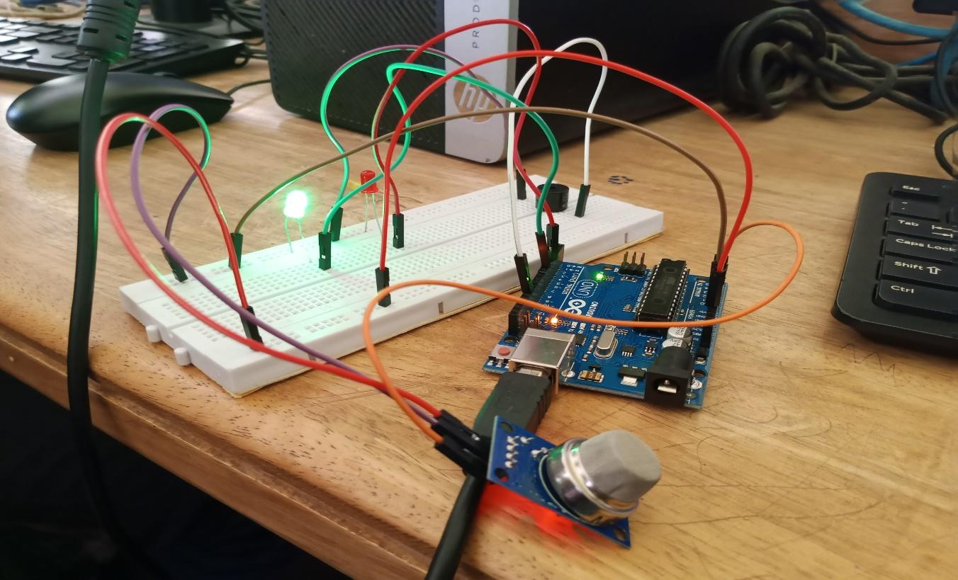

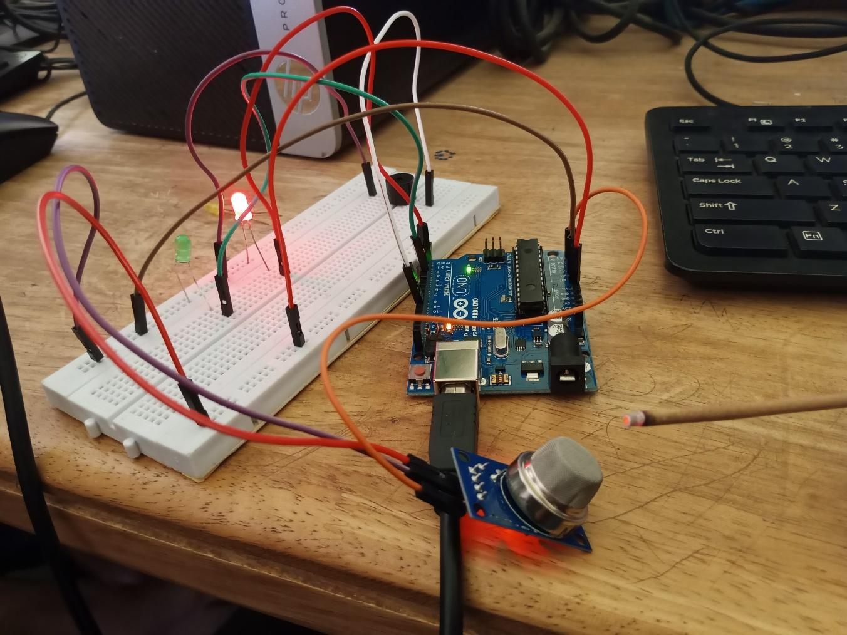

**Conclusion:**

I want to conclude that we have understood about the MQ2 gas sensor.We also learned about the working principle of the MQ-2 gas sensor, and its integration with Arduino Uno and Arduino Nano boards. Application of this sensor opens doors for creating advanced applications involving gas detection and other sensor-based systems. We executed this experiment successfully and got our respective results.